**EXPERIMENTAL INVESTIGATION OF A FOUR STROKE DIESEL ENGINE FUELLED WITH NASEBERRY SEED OIL AS A POTENTIAL ALTERNATIVE FUEL FOR HEAVY-DUTY VEHICLES FOR A GREENER ENVIRONMENT**

**A PROJECT REPORT**

***Submitted by***

|  |  |
| --- | --- |
| **SHANMUGA VIGNESH S** | **(142219114060)** |
| **SRIRAM R** | **(142219114063)** |
| **SRIVATHSUN M** | **(142219114064)** |
| **YOGESHKUMAR S** | **(142219114067)** |

***in partial fulfilment for the award of the degree***

***of***

**BACHELOR OF ENGINEERING**

**IN**

# MECHANICAL ENGINEERING

**SRM VALLIAMMAI ENGINEERING COLLEGE**

**(An Autonomous Institution)**

**CHENGALPATTU.**

**ANNA UNIVERSITY, CHENNAI-600025**

MAY 2023

**BONAFIDE CERTIFICATE**

Certified that this project report **“EXPERIMENTAL INVESTIGATION OF A FOUR-STROKE DIESEL ENGINE FUELLED WITH NASEBERRY SEED OIL AS A POTENTIAL FUEL FOR HEAVY-DUTY VEHICLES FOR A GREENER ENVIRONMENT”** is the bonafide work of

|  |  |
| --- | --- |
| **SHANMUGA VIGNESH S** | **(142219114060)** |
| **SRIRAM R** | **(142219114063)** |
| **SRIVATHSUN M** | **(142219114064)** |
| **YOGESHKUMAR S** | **(142219114067)** |

who carried out the project work under my supervision.

|  |  |
| --- | --- |
| **SIGNATURE** | **SIGNATURE** |
| **Dr. S.THIRUGNANAM, M.E.,Ph.D.** | **Dr. S. SURESH PUNGAIAH M.E., MBA., Ph.D.** |
| **HEAD OF THE DEPARTMENT** | **Assistant Professor/ Project Supervisor** |
| Mechanical Engineering, | Mechanical Engineering, |
| SRM Valliammai Engineering College, | SRM Valliammai Engineering College, |
| Kattankulathur-603 203, | Kattankulathur-603 203, |
| Chengalpattu District. | Chengalpattu District. |

Submitted for the viva-voice examination held on _____________

# INTERNAL EXAMINER EXTERNAL EXAMINER

# ACKNOWLEDGEMENT

I express my profound thanks to our Correspondent **Ms. R. Harini, M.Sc., SRM Valliammai Engineering College** for providing a congenial study environment and all sorts of resources required for the academics.

I sincerely thank our beloved director **Dr. B. CHIDAMBARARAJAN, M.E., Ph.D., SRM Valliammai Engineering College** for providing a comfortable study environment and all necessary academic resources.

I express my profound thanks to our beloved principal **Dr. M. MURUGAN, M.E., Ph.D., SRM Valliammai Engineering College** for providing a congenial study environment and all sorts of resources required for the academics.

I also express my sincere thanks to our vice principal **Dr. H. KRISHNAN, M.E., Ph.D., SRM Valliammai Engineering College** for his valuable support throughout the course of study.

I take this opportunity to express my sincere thanks to **Dr. S. THIRUGNANAM, M.E., Ph.D.,** Head of the Department, Mechanical engineering for providing all facilities and valuable suggestion to complete this project work.

The inception and the rudimentary concepts and ideas of project are ascribable to my guide **Dr. S. SURESH PUNGAIAH, M.E., MBA., Ph.D.,** Assistant Professor (O.G), Department of Mechanical engineering, without whose invaluable guidance, patience and encouragement, anything would have materialized.

I take this opportunity to express my deep sense of gratitude to my project coordinator, **Mr.P.RAMU, M.E.,** Assistant Professor, for his excellent guidance, continuous motivation and constant encouragement which have stimulated me to make a remarkable steps into my project.

I thank all the teaching, non-teaching staffs of our department and our parents for rendering their guidance and support for the completion of our project.

**ABSTRACT**

A heavy-duty vehicle should be efficient, feasible, and cost-effective. If these conditions are not met, the concepts are dropped. Electric heavy trucks will have a shorter loading span, a shorter travel distance between recharges, and will be more expensive.

The majority of heavy vehicles, buses, and tractors in India and around the world are powered by diesel engines that run on diesel fuel. India's primary energy supply must be boosted three to four times. New energy sources, such as biofuels, may play a major role in meeting energy demands.

The primary goal of this novel work is to characterize the performance, combustion, and emission properties of biodiesel generated from naseberry seeds using the transesterification process as a potential alternative feedstock for diesel engines. Experimentally, the physio-chemical characteristics of Naseberry seed methyl ester (NSME) were determined and compared to those of base fuel. Three different concentrations of test fuel were prepared: B20 (20 percent naseberry seed oil and 80 percent diesel, B40,B40+Al2O3 and B100. Experiments with varied load conditions were undertaken at a constant speed, injection timing of 23° crank angle, and compression ratio of 17.5:1 to evaluate the diesel engine characteristics. NSME 20 has a higher thermal efficiency compared to other blends and pure NSME. NSME 20 also has 1.61% more mechanical efficiency compared to pure diesel. It emits less nitrogen oxides compared to diesel. According to the analysis of experimental data, the nitrogen oxides of NSME 20 is less comparatively. It also follows a similar trend to that of diesel in specific fuel consumption as well as smoke opacity. However, hydrocarbon and carbon monoxide emissions are slightly increased.

**LIST OF FIGURES**

**Fig 1.1: Block Diagram of the Proposed System**

**Fig 3.1 Photosynthesis equation**

**Fig 3.2 Biomass Energy cycle**

**Fig 3.3 Types of Biofuels**

**Fig 4.1 Biodiesel Production steps**

**Fig 4.2 Transesterification reaction**

**Fig 4.3 Transesterification process for Biodiesel**

**Fig 4.4 Basic Transesterification reaction with methanol**

**Fig 4.5 Basic Transesterification reaction with ethanol**

**Fig 5.1 Stirrer**

**Fig 5.2 Separation funnel for Naseberry Biodiesel and glycerol**

**Fig 5.3 Magnetic Stirrer**

**Fig 5.4 Different blends of biodiesel and diesel**

**Fig 5.5 AVL smoke meter and AVL Di - gas analyser**

**Fig 5.6 Kirloskar TV 1 Engine setup**

**Fig 5.7 Blending of biodiesel**

**Fig 6.1: Graphical Representation of Specific fuel consumption**

**Fig 6.2: Graphical Representation of Brake thermal efficiency**

**Fig 6.3: Graphical Representation of Mechanical efficiency**

**Fig 6.4: Graphical Representation of Carbon monoxide level**

**Fig 6.5: Graphical Representation of Hydro Carbon level**

**Fig 6.6: Graphical Representation of Nitrogen Oxides level**

**Fig 6.7: Graphical Representation of Opacity level**

**LIST OF TABLES**

**Table 5.1: Properties of diesel and biodiesel**

**Table 5.2: Engine Specifications**

**Table 5.3: Observation Data for B20**

**Table 5.4: Observation Data for B40**

**Table 5.4.1: Observation Data for B40+Al2O3**

**Table 5.5: Observation Data for B100**

**Table 5.6: Observation Data for Diesel**

**Table 5.7: Emission Observation Data for B20**

**Table 5.8: Emission Observation Data for B40**

**Table 5.8.1: Emission Observation Data for B40+Al2O3**

**Table 5.9: Emission Observation Data for B100**

**Table 5.10: Emission Observation Data for Diesel**

**Table 6.1 Result Data for B20**

**Table 6.2 Result Data for B40**

**Table 6.2.1 Result Data for B40+Al2O3**

**Table 6.3 Result Data for B100**

**Table 6.4 Result Data for Diesel**

**LIST OF SYMBOLS**

**NSME -** NASEBERRY SEED METHYL ESTER

**FFAME -**  FAME FATTY ACID METHYL ESTER

**SFA -**  SATURATED FATTY ACIDS

**FFA** – FREE FATTY ACIDS

**NSFA -**  NON SATURATED FATTY AICDS

**CO –** CARBON MONOXIDE

**HC -**  HYDRO CARBON

**NOX -**  NITROGEN OXIDE

**BP -**  BRAKE POWER

**IP –** INDICATED POWER

**TFC –** TOTAL FUEL CONSUMPTION

**CV -**  CALORIFIC VALUE

**BDC –** BOTTOM DEAD CENTRE

**TDC –** TOP DEAD CENTRE

**TABLE OF CONTENTS**

|  |  |  |  |  |  |
| --- | --- | --- | --- | --- | --- |
| **CHAPTER.NO.** |  |  | | **TITLE** | **PAGE NO.** |
|  | **ABSTRACT** | | |  |  |
|  | **LIST OF TABLE** | | | |  |
|  | **LIST OF FIGURES** | | | |  |
|  | **LIST OF SYMBOLS** | | | |  |
| **1** | **INTRODUCTION** | | | |  |
|  | 1.1 | WORK PLAN | | | 1 |
| **2** | **LITERATURE REVIEW** | | | |  |
|  | 2.1 LITERATURE REVIEW | | | |  |
|  | 2.2 OBJECTIVES | | | |  |
|  | 2.3 METHODOLOGY | | | |  |
| **3** | **BIO-ENERGY** | | | |  |
|  | 3.1 | BIOENERGY | | | 1 |
|  | 3.2 | BIOMASS | | | 1 |
|  |  | 3.2.1 | | BIOMASS SOURCES |  |
|  | 3.3 | BIOFUEL – AN ALTERNATIVE FUEL | | | 1 |
|  |  | 3.3.1 | | TYPES OF BIOFUEL |  |
|  |  | 3.3.2 | | GENERATION OF BIOFUELS |  |
|  |  | 3.3.3 | | COMMON TYPES OF BIOFUELS |  |
|  | 3.4 | BIODIESEL | | | 1 |
|  |  | 3.4.1 | | ADVANTAGES OF BIODIESEL |  |
|  |  | 3.4.2 | | ADVANTAGES OF NANOADDITIVES |  |
|  | 3.5 | BIODIESEL SCOPE IN INDIA | | | 1 |
| **4** | **BIODIESEL PRODUCTION** | | | |  |
|  | 4.1 | CHARACTERISTICS OF RAW MATERIALS | | | 1 |
|  | 4.2 | CHARACTERISTICS OF OILS AND FATS USED IN BIODIESEL PRODUCTION | | | 1 |
|  | 4.3 | CHARACTERISTICS OF ALCOHOLS USED IN BIODIESEL PRODUCTION | | | 1 |
|  | 4.4 | CHARACTERISTICS OF CATALYSTS AND NEUTRALIZERS USED IN BIODIESEL PRODUCTION | | | 1 |
|  | 4.5 | STAGES OF BIODIESEL PRODUCTION PROCESS | | | 1 |
|  |  | 4.5.1 | | TREATMENT OF RAW MATERIALS |  |
|  |  | 4.5.2 | | ALCOHOL-CATALYST MIXING |  |
|  |  | 4.5.3 | | TRANSESTERIFICATION |  |
|  |  | 4.5.4 | | CATALYSTS USED FOR TRANSESTERIFICATION |  |
|  |  | 4.5.5 | | SEPARATION OF THE REACTION PRODUCTS |  |
|  |  | 4.5.6 | | PURIFICATION OF BIODIESEL |  |
| **5** | **EXPERIMENTAL SETUP AND PROCEDURE** | | | |  |
|  | 5.1 | PREPARATION OF NASEBERRY SEED OIL | | | 1 |
|  | 5.2 | PREPARATION OF BIODIESEL | | | 1 |
|  | 5.3 | CHARACTERISTICS ANALYSIS TEST OF PURE BIODIESEL | | | 1 |
|  | 5.4 | WORK PROCESS DETAILS | | | 1 |
|  | 5.5 | EXPERIMENTAL SETUP | | | 1 |
|  |  | 5.5.1 | | ENGINE SETUP |  |
|  | 5.6 | OBSERVATION DATA | | | 1 |
|  |  | 5.6.1 | | PERFORMANCE TEST |  |
|  |  | 5.6.2 | | EMISSION TEST |  |
|  | 5.7 | CALCULATION | | | 1 |
| **6** | **RESULTS AND CONCLUSION** | | | |  |
|  | 6.1 | PERFORMANCE RESULT DATA | | | 1 |
|  | 6.2 | PERFORMANCE GRAPHS | | |  |
|  |  | 6.2.1 | SPECIFIC FUEL CONSUMPTION | |  |
|  |  | 6.2.2 | BRAKE THERMAL EFFICIENCY | |  |
|  |  | 6.2.3 | MECHANICAL EFFICIENCY | |  |
|  | 6.3 | PERFORMANNCE CHARACTERISTICS | | | 1 |
|  | 6.4 | EMISSION GRAPHS | | |  |
|  |  | 6.4.1 | CARBON MONOXIDE | |  |
|  |  | 6.4.2 | HYDROCARBON | |  |
| 6.4.3 | NITROGEN OXIDES | |
| 6.4.4 | OPACITY | |
|  | 6.5 | EMISSION CHARACTERISTICS | | |  |
|  | 6.6 | CONCLUSION | | |  |
|  | **REFERENCES** | | |  |  |

Chapter 1

**INTRODUCTION**

Heavy trucks powered by electricity are not developed as they are made to carry heavy loads to far destinations. this would require high power motor (i.e., bigger motor) and bigger batteries (to power them for a long time). But unlike a passenger vehicle, trucks have space constrain to pack the larger motor & batteries. A truck should be efficient, feasible & affordable. When these are not met, the concepts are dropped. Electric powered heavy trucks will have shorter loading span, shorter travel distance between recharges & costly. Diesel is predominantly employed in urban mobility and transportation modalities such as public transit, private transportation, and freight transportation.

Carbon emissions from the use of fossil fuels have been identified as one of the primary drivers of global warming today. Over the last few decades, pollution levels have increased at an alarming rate. This necessitates the implementation of coordinated initiatives to reduce pollution from multiple sources. The automobile industry has been highlighted as being one of the top sources of fossil fuel emissions; this can be due to the widespread use of fossil fuels in automobiles on the roads across the world.  The number of automobiles on the road is predicted to rise in tandem with the urban population. As a result, increasing vehicle deployment owing to urbanisation and industrialization will increase diesel fuel consumption. In 2021, global diesel consumption reached 27955 thousand barrels per day, representing a 1.3 percent increase from the previous year. Diesel as a fuel is expected to rise significantly in the transportation sector around the world. The majority of heavy vehicles, buses, and tractors in the India and around the world are powered by diesel engines that run on diesel fuel.

The majority of diesel fuel used in diesel engines is processed from crude oil, and global crude oil production in 2021 was 83182 thousand barrels per day. Energy drives economic growth and is vital to the modern economy and civilization's long-term existence.

This increase of energy demand has been supplied by the use of fossil resources, which has been a major reason for the crises of the fossil fuel depletion, the increase in its price and the serious environmental impacts as global warming, acidification, deforestation, ozone depletion and photochemical smog. Major energy demands in India is met with Coal, Oil and Biomass. Alternative clean energy sources are required to suffice the damage that has taken place over the years. Even though there are new sources that are found, rather than fully transitioning which might take quite a while especially in case of heavy-duty vehicles, it is required to make immediate affordable yet efficient changes. Our future economic growth is strongly reliant on reliable, safe, and affordable energy sources. India's primary energy supply needs be tripled or quadrupled to achieve 8% annual growth. Biofuels, for example, may help meet energy demands. Similar to fossil fuels, biofuels exist in solid, liquid, and gaseous forms. In order to minimise dependency on fossil fuels and combat climate change, many people encourage the production and use of biofuels as alternatives to fossil fuels like conventional diesel fuel. Biofuels are essential in the energy business since they burn like fossil fuels. Biofuel is any fuelthat is derived from biomass—that is, plant or algae material or animal waste. Biodiesel is arenewable, biodegradable fuel manufactured domestically from vegetable oils, animal fats or algae. The cetane number (CN), lubricity, flash point, biodegradability, renewability and carbon footprint all beat diesel.

Naseberry fruits, also known as sapodillas (Manikara Zapota), are found in southern Mexico, the Caribbean, and Central America. It is also widely grown in India, Thailand, Cambodia, Malaysia, Indonesia, and Bangladesh, primarily for its fruit. In Northern India, it is also known as chikoo (chiku), and in Southern India, it is known as sapota. It is an evergreen tree that grows in all tropical regions, from the moist tropics to the dry chilly subtropics. Despite the fact that the tree flowers and fruits all year, the maximum production occurs only from March to June. Figure 1 depicts a photograph of Naseberry tree, fruits and seeds.

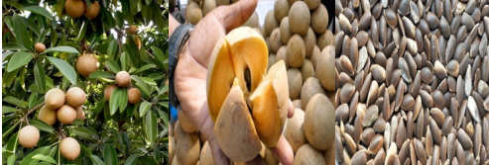

Naseberry is a fruit with sweet, juicy flesh and a tough brownish skin that contains 1-12 brown or black seeds. It is consumed fresh or processed into jam and juice. Except for planting, the seeds are not used for anything else. Because Naseberry seeds contain an oil content of 23-30%, this underutilised oil seed can be explored for biodiesel production. According to scientific estimates, over 50 tonnes of seeds are wasted in the Tamil Nadu region alone each year, yielding 12.5 tonnes of oil. The concept is significant in light of the state's high need for edible oil, which is met by domestic production and importation from other states.

* 1. **WORK PLAN**

**Fig 1.1: Block Diagram of the Proposed System**

Chapter 2

**LITERATURE REVIEW**

**2.1 LITERATURE REVIEW**

[*Shweta J.Malode*](https://www.sciencedirect.com/science/article/pii/S2590174520300428#!) *et.al. (2021)* have highlighted the use of dreck organic matters from aquathe tic environment and soil supplies for renewable energy production for human requirements, sustaining a clean and healthy environment. The key focus of this study is the recent advances in the area of ’synchronous waste mitigation with energy development’ techniques. This review addresses the significance of organic substances for the production of clean and renewable energy, including alternate solutions for non-renewable fuels. In the case of third-age biofuels, they are still in the beginning phase of advancement. The financial attainability of these cycles will be sought out after an objective. Commercialization requires propelling lab-scale cycles to improve yields and productivity. Specific biomass feedstocks and techniques are used to generate biofuels. Biofuel production uses human foodstuffs such as maize, peanuts, sugarcane, soya, and is increasingly criticized for creating competition between crops as food and as raw material for biofuels.

[*Chris Ruehl*](https://www.tandfonline.com/author/Ruehl%2C+Chris) *et.al. (2021)* has proposed that over the past decade, efforts to reduce emissions of particulate matter (PM) and oxides of nitrogen (NO + NO2, or NO*x*) from heavy-duty diesel vehicles (HDDVs) have led to the widespread adoption of both Diesel Particulate Filters (DPFs) to control PM and Selective Catalytic Reduction (SCR) to control NO*x.* Black Carbon emission factors have decreased by 90% during the past decade. To help describe the relationship between Black carbon emissions and age at the fleet level (i.e., incorporating all observations), we use a "gross emitter" model. It assumes emissions are constant until a failure of the aftertreatment system occurs, at which point emissions step to a new, higher constant value.

[*Kaniki Tumba*](https://www.frontiersin.org/people/u/823557) *et.al. (2021)* has stated that Oils derived from plant seeds and microalgae comprise mainly triacylglycerols (TAG) molecules with very high energy density, making them an ideal source for biofuels. These renewable energy sources for transportation are increasingly in demand by societies because they do not raise global carbon dioxide levels. The most common biofuel derived from seed oils is biodiesel, which consists of the fatty acid methyl esters (FAME) produced from the TAG molecules. More recently, renewable aviation fuels termed “biojet” have been synthesized from seed oils through hydroprocessing. The economics of production limits the widespread adoption of fuels derived from seed and microalgal oils. While increasing seed oil production would help offset these problems, it should be done in a sustainable manner that does not destroy existing ecosystems or compete with food production. Also, biodiesel derived from some vegetable oils suffers poor cold-temperature properties and is prone to oxidation compared to conventional diesel.

[*Konstantin Pikula*](https://www.tandfonline.com/author/Pikula%2C+Konstantin) *et.al (2020)* has proposed some important insights into the recent advances in the biodiesel industry including biodiesel production from microalgal lipids, advanced homogenous and enzymatic transesterification, non-catalytic supercritical transesterification, application of microwave and ultrasound assisting technologies. This study was to identify the difference between conventional and novel technologies applied during the whole life cycle of biodiesel production and consumption. The efficiency of the biodiesel industry significantly depends on the achievements of oil extraction from raw biomass and biodiesel production technology. Enzymatic and supercritical extraction and transesterification technologies are capable to replace conventional chemical methods.

*Weder N. Ferreira Junior et.al. (2020)* has proposed that thermodynamic properties are influenced by the moisture content and temperature, with an increase in the energy required to remove water from the product with a decrease in moisture content. Drying stands out among the most used processes for maintaining the quality of plant products after harvest, as it is an indispensable technique for the quality control of plant products. The knowledge of this moisture content reduction process, which simultaneously involves the transfer of heat and mass, is essential for efficient drying at technical and economic levels. The latent heat of vaporization, the differential enthalpy, and the Gibbs free energy increase with a reduction of the moisture content of naseberry seeds.

[*Theodoros Grigoratos*](https://www.sciencedirect.com/science/article/pii/S1352231019300056#!) *et.al. (2019)* has proposed that despite that Heavy-Duty Vehicles (HDVs) represent a small part of the overall vehicle population they have been identified as one of the most important contributors to air pollution. This is one of the reasons why HDV emissions regulations are becoming more and more stringent worldwide. However, relatively high emissions were observed for some of the pollutants over low-speed phases due to reduced effectiveness of the corresponding emission control systems.

*Montcho Papin S et.al. (2018)* has reviewed a Comparative Study of Transesterification Processes for Biodiesel Production that due to the environmental problems caused by the use of fossil fuels, attention has been paid to the production of biodiesel as an alternative to petrol and diesel. Biodiesel is an environmentally friendly alternative diesel fuel made from renewable resources made from vegetable oils and animal fats. It is a renewable energy source that seems to be an ideal solution for global energy needs. The current method of biodiesel production is the transesterification of the inedible oil with an alcohol (methanol or ethanol) in the presence of a catalyst or not. The transesterification reaction is very sensitive to the parameters and oil nature such as the acid composition and the free fatty acid content. Other variables include reaction such as temperature, ratio of alcohol to vegetable oil, catalyst, and intensity of mixing, purity of reagents.

# *Rajalingam. A. et.al. (2016)* have reviewed that the Production methods of biodiesel and its effect. An alternative fuel should be found to compensate the future fuel demand and reduce pollution. The vegetable oil/animal fat has a high energy density to meet the energy compensation, but its properties are not favorable for better atomization so can be converted in to biodiesel. Generally, four methods are used to produce biodiesel from vegetable oils which are blending, transesterification process, pyrolysis and micro emulsion. Some important factors that should be consider in the production of biodiesel are cost, property, production methodology, required equipment, etc., Considering the above factors transesterification process is the most suitable one. It will give a better fuel quality and yield efficiency. It also does not require any complicated special equipment. The glycerol will obtain as a bi-product of a process. Because of the above reasons the transesterification process can be the better biodiesel production process than others.

R. SATHISH KUMAR (2017) a comparative analysis of enrichment of hydrogen alongside diesel fuel and two different sources of biodiesel namely rice bran oil is an edible oil, and karanja oil being non-edible is tested.Hydrogen at a fixed flow rate of 7 lpm is inducted through the intake manifold. A total of six fuel samples are considered: diesel (D), hydrogen-enriched diesel (D þ H2), hydrogen-enriched 10, and 20% rice bran biodiesel blend (RB10 þ H2 and RB20 þ H2), and hydrogen-enriched 10 and 20% karanja biodiesel blend (KB10 þ H2 and KB20 þ H2).Results indicate that enrichment of hydrogen improves combustion and results in 2.5% and 1.6% increase in the brake thermal efficiency of diesel fuel and rice bran biodiesel, respectively[34].

*Mingxin Guo et.al. (2014)* has analyzed the history, status, and perspective of bioenergy and biofuels. It is reviewed that solid biofuels are most available in source materials, most efficient in feedstock energy recovery, and most effective in conversion technology and production cost, but the products are bulky, inconvenient to handle, low in energy density, and only applicable to solid fuel burners. Liquid biofuels are energy-dense, convenient to transport, and can substitute for gasoline and petrol diesel. However, they are low in net energy efficiency, have stringent requirements for feedstocks, and involve complicated conversion technology and high production cost. Gaseous biofuels can be produced from organic waste materials and residues using well-practiced techniques, yet there are by-product disposal challenges.

**2.2 OBJECTIVE**

* To create jobs in rural areas.
* To promote renewable energy by utilising biofuel energy.
* To Reduce the import bill of oil for the country/State and increase the supply of organic manure.
* To reduce hazardous emissions during the combustion of biofuel, which is virtually sulphur-free.
* To reduce greenhouse gas emissions by substituting plant oil-based fuels for fossil fuels.

**2.3 METHODOLOGY**

* The engine was coupled to an eddy current dynamometer for load measurement.
* Hydrocarbon, Carbon dioxide, Carbon monoxide, Oxygen and Oxides of nitrogen were measured by using AVL Di – gas analyser.
* Smoke was measured by using AVL smoke meter.
* The experiments were performed at load test; the engine was allowed to run with diesel at variable loads of No load, 25%, 50%, 75% and 100% at rated speed of 1500 rpm with full load of 5.2 kW.
* After completing the experiment with Diesel, the experiment was conducted with B20, B40 and B100 respectively.

**Chapter 3**

**BIO-ENERGY**

**3.1 BIOENERGY**

Bioenergy, is the energy that is derived from living or lived once biological organisms. It is defined as the organic matter which are directly or indirectly from plants that can be converted into fuel and is acts as energy source. It is a form of renewable energy which can be used to produce transportation fuels, heat, electricity, and products.

Bioenergy use falls into two main categories: “traditional” and “modern”. Traditional use refers to the combustion of biomass in such forms as wood, animal waste and traditional charcoal. Modern bioenergy technologies include liquid biofuels, biogas produced through anaerobic digestion of residues and wood pellet heating system. About three-quarters of the world’s renewable energy use involves bioenergy, with more than half of that consisting of traditional biomass use.

**3.2 BIOMASS**

Biomass is a renewable energy resource derived from plant- and algae-based materials. Biomass is a versatile renewable energy source. It can be converted into liquid transportation fuels that are equivalent to fossil-based fuels, such as gasoline, jet, and diesel fuel. Bioenergy technologies enable the reuse of carbon from biomass and waste streams into reduced-emissions fuels for cars, trucks, jets and ships; bioproducts; and renewable power.

Biomass has always been an important energy source for the country considering the benefits it offers.  It is renewable, widely available, carbon-neutral and has the potential to provide significant employment in the rural areas.  Biomass is also capable of providing firm energy.  In India, about 32% of the total primary energy use in the country is still derived from biomass and more than 70% of the country’s population depends upon it for its energy needs. Biomass contains stored chemical energy from the sun. Plants produce biomass through [photosynthesis](https://www.eia.gov/tools/glossary/index.php?id=Photosynthesis). Biomass can be burned directly for heat or converted to renewable liquid and gaseous fuels through various processes. During photosynthesis, plant convert energy absorbed from sun into chemical energy. This chemical energy is in the form of sugar or glucose.

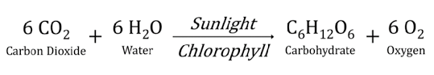

**Fig 3.1 Photosynthesis equation**

**3.2.1 Biomass sources**

* [Wood and wood processing wastes](https://www.eia.gov/energyexplained/biomass/wood-and-wood-waste.php)—firewood, wood pellets, and wood chips, lumber and furniture mill sawdust and waste.
* Agricultural crops and waste materials—corn, soybeans, sugar cane, switchgrass, woody plants, and algae, and crop and food processing residues
* Biogenic materials in [municipal solid waste](https://www.eia.gov/energyexplained/biomass/waste-to-energy.php)—paper, cotton, and wool products, and food, yard, and wood wastes
* Animal manure and human sewage

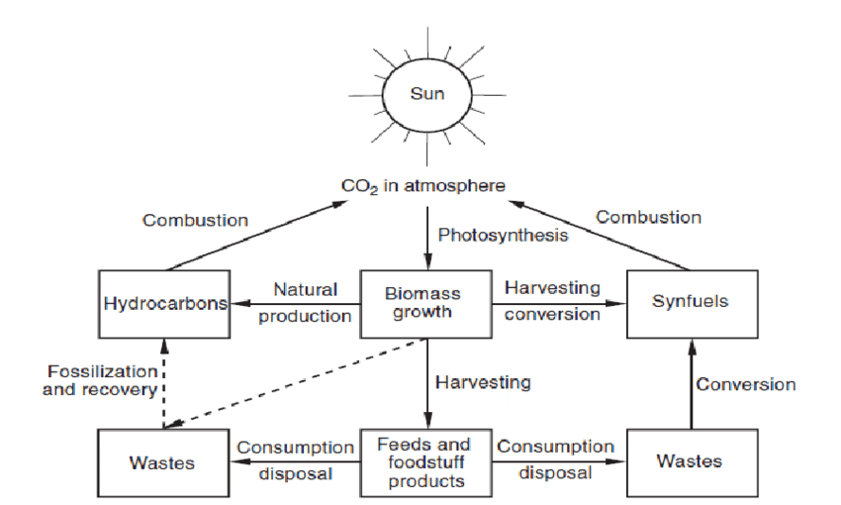

**Fig 3.2 Biomass Energy cycle**

**3.3 BIOFUEL – AN ALTERNATIVE FUEL**

Biofuel technology has evolved in recent years, and it has been approved in several countries as a viable alternative to fossil fuels such as gasoline and diesel. The most popular bio-fuel technology focuses on the manufacture of biofuels from biomass-based wastes, such as agricultural manure, agricultural residues, and animal by-products. One of the most compelling arguments for using biofuels technology is the enormous amount of waste products that are easily accessible. Most of these wastes can be found in high concentrations in local areas, and the conversion of wastes to biofuels also stimulates the production of another by-product that can be used as fertilizer. The term biofuels usually applies to liquid fuels and blending components produced from biomass materials called feedstocks. Most biofuels are used as transportation fuels, but they may also be used for heating and electricity generation. Gaseous fuels produced from biomass that are used directly as a gas or converted to liquid fuels may qualify for use in government programs that promote or require use of biofuels.

**3.3.1 Types of Biofuel**

Biofuels may be generally grouped into the following categories:

1. Those produced by fermentation into alcohols;
2. Oils separated from biomass and reacted to form hydrocarbons or fatty acid methyl esters
3. Oils processed by hydrogenation to produce hydrocarbons within the carbon range of conventional petroleum fuels.

Primary biofuels are defined as organic materials that are deployed as an energy source immediately, without any prior treatment or processing. Some examples of primary biofuels include timber, wood chips, pellets and other types of wood that is traditionally used for heating and cooking purposes, especially in developing countries where no other fuel source is available.

Secondary biofuels refer to any form of biomass that is used to generate energy after it has been processed. Examples of secondary biofuels include liquid biofuels that are becoming increasingly popular in the transportation industry, such as bioethanol and biodiesel. These are also used in industrial processes and biomass power plants, as well.

**3.3.2 Generation of Biofuels**

1. First generation biofuels -

First generation biofuels, also known as conventional biofuels, are made from sugar, starch or vegetable oil. First generation biofuels are produced through well-understood technologies and processes, like fermentation, distillation and transesterification. These processes have been used for hundreds of years in many uses, such as making alcohol. Sugars and starches are fermented to produce primarily ethanol, and in smaller quantities, butanol and propanol. Ethanol has one-third of the energy density of gasoline, but is currently used in many countries, including the United States, as an additive to gasoline. A benefit of ethanol is that it burns cleaner than gasoline and therefore produces less greenhouse gases. Another 1st generation biofuel, called biodiesel, is produced when plant oil or animal fat goes through a process called transesterification. This process involves exposing oils with an alcohol such as methanol in the presence of a catalyst. The distillation process involves separating the main product from any of the by-products of the reactions.

2. Second generation biofuels -

The biomass sources for 2nd generation biofuels include wood, organic waste, food waste and specific biomass crops. Fast growing trees such as poplar trees need to undergo a pre-treatment step, which is series of chemical reactions that break down lignin, the “glue” that holds plants together, in order to make fuel. Second generation biofuels address many issues associated with 1st generation biofuels. Second generation biofuels also generate higher energy yields per acre than 1st generation fuels. They allow for use of poorer quality land where food crops may not be able to grow. The technology is fairly immature, so it still has potential of cost reductions and increased production efficiency as scientific advances occur.

3. Third generation biofuels -

Third generation biofuels use specially engineered crops such as algae as the energy source. These algae are grown and harvested to extract oil within them. The oil can then be converted into biodiesel through a similar process as 1st generation biofuels, or it can be refined into other fuels as replacements to petroleum-based fuels. Third generation biofuels are more energy dense than 1st and 2nd generation biofuels per area of harvest. They are cultured as low-cost, high-energy, and completely renewable sources of energy. Algae are advantageous in that it can grow in areas unsuitable for 1st and 2nd generation crops, which would relieve stress on water and arable land used. It can be grown using sewage, wastewater, and saltwater, such as oceans or salt lakes.

**3.3.3 Common types of Biofuels**

The two most common types of biofuels in use today are ethanol and biodiesel, both of which represent the first generation of biofuel technology.

1. Ethanol - Ethanol is pure alcohol or ethyl alcohol and is probably the most common alternative biofuel used in motor vehicles today. Ethanol (CH3CH2OH) is a renewable fuel that can be made from various plant materials. Ethanol can be made using different sources, but the most commonly used are sugarcane and corn. The common method for converting biomass into ethanol is called fermentation. During fermentation, microorganisms (e.g., bacteria and yeast) metabolize plant sugars and produce ethanol. Ethanol is made by fermenting sugars derived from sugarcane or corn, and it contains oxygen, which helps a vehicle’s engine efficiently burn fuel, reducing emissions. Ethanol contains less energy per gallon than gasoline, to varying degrees, depending on the volume percentage of ethanol in the blend. Ethanol is an alcohol used as a blending agent with gasoline to increase octane and cut down carbon monoxide and other smog-causing emissions.
2. Biodiesel- Biodiesel is derived from recycled cooking grease, animal fat, vegetable oils usually. Biodiesel is nontoxic and biodegradable and is produced by combining alcohol with vegetable oil, animal fat, or recycled cooking grease. Biodiesel is fuel made up of mono-alkyl esters of long chain fatty acids derived from biomass-based oils such as vegetable oils or animal fats. It can be produced by a transesterification reaction between the fatty acid and an alcohol, usually methanol, to produce a fatty acid alkyl ester. The distribution of carbon ranges will mirror the carbon lengths in the fatty acid feedstock.

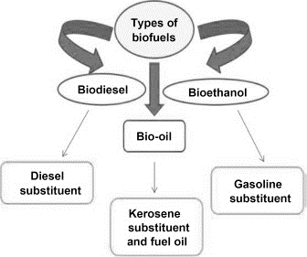

**Fig 3.3 Types of Biofuels**

**3.4 BIODIESEL**

* Biodiesel is a domestically produced, renewable fuel that can be manufactured from vegetable oils, animal fats, or recycled restaurant grease for use in diesel vehicles or any equipment that operates on diesel fuel.
* Biodiesel is a liquid fuel often referred to as B100 or neat biodiesel in its pure, unblended form.
* Like petroleum diesel, biodiesel is used to fuel compression-ignition engines.
* Biodiesel is derived from recycled cooking grease, animal fat, vegetable oils usually.
* Biodiesel is nontoxic and biodegradable and is produced by combining alcohol with vegetable oil, animal fat, or recycled cooking grease.
* Biodiesel is intended to be used as a replacement for petroleum diesel fuel, or can be blended with petroleum diesel fuel in any proportion.
* Biodiesel is fuel made up of mono-alkyl esters of long chain fatty acids derived from biomass-based oils such as vegetable oils or animal fats.
* It can be produced by a transesterification reaction between the fatty acid and an alcohol, usually methanol, to produce a fatty acid alkyl ester.

Similar to any other fuel source, biofuel has its advantages and disadvantages. The advantages and disadvantages depend on the categorization of the specific biofuel, type of feedstock used and technology applied to produce it. Taking the same feedstock or vegetable waste and applying different technology to produce it, can vary results.

**3.4.1 Advantages of Biodiesel**

* It is a type of Renewable energy, obtained from vegetable oils, algae, fruit seed oil or animal fats.
* No sulfur dioxide (SO2) emissions. Bioethanol and Biodiesel contain smaller concentrations of chemicals like chlorine and sulphur compared to fossil fuels.
* It is the only alternative fuel usually blend, that can be used in a conventional diesel engine, without modifications.
* May be blended with diesel fuel at any proportion; both fuels may be mixed during the fuel supply to vehicles.
* Lower health risk, due to reduced emissions of carcinogenic substances. Pollution is reduced.
* Degradable hence reducing environment risks such spills.
* Excellent properties as a lubricant.
* Lower emissions of contaminants: carbon monoxide, particulate matter, polycyclic aromatic hydrocarbons, aldehydes.
* Low toxicity, in comparison with diesel fuel.
* Higher flash point (100°C minimum).
* Used cooking oils and fat residues from meat processing may be used as raw materials.
* Biodiesel can be produced locally thus resulting in employment in that region.
  + 1. **Advantages of Nano additives (Al2O3)**
* Al2O3 with biodiesel will increases the oxidation rate and decreases the ignition temperature.
* Al2O3 contains high temperature at the time of reactions with oxygen. Al2O3 is unstable during the combustion in high temperature, methyl ester added to nano additives will improves the combustion, better performance of engines and the fuel suspensions stability will be increased in CRDI system.
* Nano additives is used as catalyst with the blends of bio fuels to enhance the reduction of emissions like NOx, CO, CO2, Smoke and Shoot emissions.
* Nano additives is used as catalyst with the blends of bio fuels to enhance the performance parameters, nano additives will increases BTE, BSFC and decreases the SFC, and to provides the better torque and to reduce cylinder temperature and friction power.

**3.5 BIODIESEL SCOPE IN INDIA**

The Biodiesel procurement by OMCs increased from 1.1 crore litres during 2015-16 to 10.56 crore litres during 2019-20. Presently, bio-diesel is being produced in the country primarily from imported palm stearin oil. India is one of the fastest growing economies and the third largest consumer of primary energy in the world after the US and China. India’s fuel energy security will remain vulnerable until alternative fuels are developed based on renewable feedstocks.

The government of India targets reducing the country’s carbon footprint by 30-35% by the year 2030. These targets will be achieved through a five-pronged strategy which includes: Increasing domestic production, adopting biofuels and renewables, implementing energy efficiency norms, improving refinery processes and achieving demand substitution. This strategy envisages a strategic role for biofuels in the Indian energy basket. The government of India has proposed a target of 20% blending of ethanol in petrol and 5% blending of biodiesel in diesel by 2030 and introduced multiple initiatives to increase indigenous production of biofuels.

India’s current aspirational blend goal for fuel ethanol is E10 by 2022, and there is no near-term blend target for biodiesel. Introduced last year, India’s National Biofuel Policy 2018 seeks to achieve a national average of E20 for gasoline and B5 for diesel by 2030. Under the new 2018 biofuels policy, the raw materials identified for production of biodiesel include non-edible oilseeds, used/waste cooking oil (UCO), animal tallow, acid oils, and algal feedstock. The National average blend rate for biodiesel in fossil diesel remains at last year’s level (0.14%) due to multiple constraints, including limited feedstock availability, lack of an integrated and dedicated supply chain, and restrictions on imports.

Chapter 4

**BIODIESEL PRODUCTION**

Biodiesel production is the process of producing the biofuel, biodiesel, through the chemical reactions of transesterification and esterification. The most important biodiesel production to ensure trouble-free operation of diesel engines aspects is complete reaction, removal of glycerol, removal of catalyst, removal of alcohol, and absence of free fatty acids. Biodiesel characteristics as a fuel vary depending on its composition, and the fuel used to be stringently monitored to avoid adverse impacts on the environment and engines. A very important consideration in the efficiency of combustion is the ignition delay in the combustion, which is influenced by the ratio of compression adopted, which in turn is related to the kind and quality of fuel used. The physicochemical properties of the biodiesel may vary depending on the source from which the mixture of fatty acids was obtained, from the transesterification and separation efficiency process.

**4.1 Characteristics of raw materials**

The primary raw materials used in the production of biodiesel are vegetable oils, animal fats, and recycled greases. These materials contain triglycerides, free fatty acids, and other contaminants. The vegetable oil used in the production of biodiesel can be obtained from various oil seeds. These species differ in their agronomic characteristics, and relative to the oil content in the composition of grain and fatty acid profile. The characteristics of the raw materials used in the manufacture of biodiesel that are considered are:

* Oil content
* Fatty acid composition
* Oxidative stability
* Low temperature properties
* Influence of the composition and acid ester content fatty raw materials on the properties of biodiesel.

**4.2 Characteristics of Oils and Fats Used in Biodiesel Production**

Oils and fats, known as lipids, are hydrophobic substances insoluble in water and are of animal or vegetal origin. From a chemical viewpoint, lipids are fatty glycerol esters known as triglycerides. Fatty acids may be saturated fatty acids (SFA) or non-saturated fatty acids (NSFA). In the former, there are only single covalent bonds in the molecules. The most frequent fatty acids in oils are lauric, palmitic, linoleic and linolenic, etc. Vegetable oils may also contain small percentages of monoglycerides and di-glycerides.

**4.3 Characteristics of Alcohols Used in Biodiesel Production**

Alcohols that can be used in biodiesel production are those with short chains, including methanol, ethanol, butanol. The most commonly used primary alcohol used in biodiesel production is methanol, although other alcohols, such as ethanol, isopropanol, and butyl, can be used. A key quality factor for the primary alcohol is the water content. Water interferes with transesterification reactions and can result in poor yields and high levels of soap, free fatty acids, and triglycerides in the final fuel.

Methanol (CH3OH) Most widely used, in spite of its toxicity. It is a substance of petrochemical origin. Methanol is considerably easier to recover than the ethanol. Ethanol forms an azeotrope with water so it is expensive to purify the ethanol during recovery. If the water is not removed it will interfere with the reactions. Methanol recycles easier because it doesn’t form an azeotrope. Ethanol (C2H5OH) is less used, requires more complex production technology and the reaction speeds are lower.

**4.4 Characteristics of Catalysts and Neutralizers Used in Biodiesel Production**

Catalysts may either be base, acid, or enzyme materials. The most commonly used catalyst materials for converting triglycerides to biodiesel are sodium hydroxide, potassium hydroxide, and sodium methoxide. The base catalysts are highly hygroscopic and they form chemical water when dissolved in the alcohol reactant. They also absorb water from the air during storage. If too much water has been adsorbed the catalyst will perform poorly and the biodiesel may not meet the total glycerin standard. Although acid catalysts can be used for transesterification, they are generally considered to be too slow for industrial processing. Acid catalysts are more commonly used for the esterification of free fatty acids.

Neutralizers are used to remove the base or acid catalyst from the product biodiesel and glycerol. If you are using a base catalyst, the neutralizer is typically an acid, and vice-versa.

**4.5 Stages of Biodiesel Production Process**

* Treatment of raw materials
* Alcohol-catalyst mixing
* Chemical reaction
* Separation of the reaction products
* Purification of the reaction products
  + 1. **Treatment of raw materials**

The content of free fatty acids, water and non-saponifiable substances are key parameters to achieve high conversion efficiency in the transesterification reaction. The use of basic catalysts in triglycerides with high content of free fatty acids is not advisable, since part of the latter reacts with the catalyst to form soaps. In consequence, part of the catalyst is spent, and it is no longer available for transesterification. In summary the efficiency of the reaction diminishes with the increase of the acidity of the oil; basic transesterification is viable if the content of free fatty acids (FFAs) is less than 2%. In the case of highly acidic raw materials. Besides having low humidity and acid content, it is important that the oil presents a low level of non-saponifiable substances. If the latter were to be present in significant amounts and soluble in biodiesel, it would reduce the level of esters in the product, making it difficult to comply with the minimum ester content required by the standards.

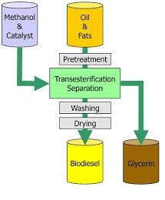

**Fig 4.1 Biodiesel Production steps**

* + 1. **Alcohol-catalyst mixing**

The alcohol used for biodiesel production must be mixed with the catalyst before adding the oil. The mixture is stirred until the catalyst is completely dissolved in the alcohol. Sodium and potassium hydroxides are among the most widely used basic cat­alysts. For production on an industrial scale, sodium or potassium methoxides or methylates are commercially available. The alcohol-to-oil volume ratio, R, is another key variable of the transesteri­fication process. A base catalysed process typically uses an operating mole ratio of 6:1 mole of alcohol rather than the 3:1 ratio required by the reaction. Usually, a 100% alcohol excess is used in practice, that is, 6 mol of alcohol per mole of oil. This corresponds to a 1:4 alcohol-to-oil volume ratio (R = 0.25). Finally, it must be noted that the necessary amount of catalyst is determined taking into account the acidity of the oil, by titration.

* + 1. **Transesterification**

This reaction requires certain conditions of time, temperature and stirring. Since alcohols and oils do not mix at room temperature, the chemical reaction is usually carried out at a higher temperature and under continuous stirring, to increase the mass transfer between the phases. Transesterification is an organic reaction in which the R group of an alcohol is exchanged with an R’ group of an ester. This is generally done via the introduction of an acid or base catalyst to the reaction mixture.

The process of transesterification can be employed for the conversion of triglycerides (an ester that is derived from three fatty acids and glycerol) into biodiesel.

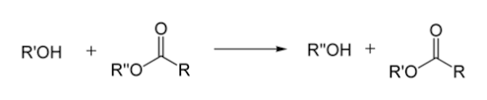

Alcohol + Triacylglycerol Glycerol + Alkyl ester

**Fig 4.2 Transesterification reaction**

Transesterification is the process in which fat or oil reacts with an alcohol to form esters and glycerol. Transesterification is extremely important for biodiesel.

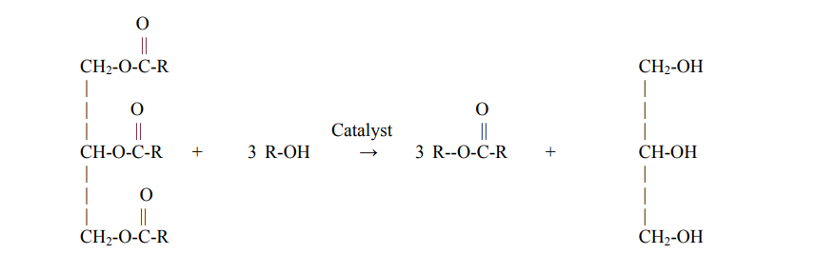Triacylglycerol Alcohol Alkyl ester Glycerol

(Vegetable oil) (Biodiesel)

**Fig 4.3 Transesterification process for Biodiesel**

When methanol is the alcohol used in the transesterification process, the product of the reaction is a mixture of methyl esters; similarly, if ethanol were used, the reaction product would be a mixture of ethyl esters. For the transesterification to occur, usually 6 moles of alcohol are used for every mole of triglyceride, which is more than the equation indicates. The catalyst used for carrying out the transesterification is usually sodium hydroxide (NaOH) or potassium hydroxide (KOH). These compounds belong to a class of materials known as bases and also are inorganic compounds. Since the boiling point of methanol is approximately 68°C (341 K), the temperature for transesterification at atmospheric pressure is usually in the range between 50 and 60°C.



**Fig 4.4 Basic Transesterification reaction with methanol**



**Fig 4.5 Basic Transesterification reaction with ethanol**

Usually, emulsions form during the course of the reaction; these are much easier and quicker to destabilize when methanol is used, in comparison to ethanol. Due to the greater stability of emulsions formed, difficulties arise in the phase separation and purification of biodiesel when ethanol is used in the reaction.

**4.5.4 Catalysts used for transesterification**

The catalysts used for the transesterification of triglycerides may be classified as basic, acid or enzymatic, as indicated.

Basic catalysts include sodium hydroxide (NaOH), potassium hydroxide (KOH), carbonates and their corresponding alcoxides (for instance, sodium methoxide or ethoxide). Acid catalysts include sulfuric acid, sulfonic acids and hydrochloric acid; their use has been less studied. Lipases are the most frequently used enzymes for biodiesel production.

#### **Separation of the Reaction Products**

The separation of reaction products takes place by decantation: the mixture of fatty acids methyl esters (FAME) separates from glycerine forming two phases, since they have different densities; the two phases begin to form immediately after the stirring of the mixture is stopped. Due to their different chemical affinities, most of the catalyst and excess alcohol will concentrate in the lower phase (glycerol), while most of the mono-, di-, and triglycerides will concentrate in the upper phase (FAME). Once the interphase is clearly and completely defined, the two phases may be physically separated. It must be noted that if decantation takes place due to the action of gravity alone, it will take several hours to complete. This constitutes a ''bottleneck'' in the production process, and in consequence the exit stream from the transesterification reactor is split into several containers. Centrifugation is a faster, albeit more expensive alternative.

After the separation of glycerin, the FAME mixture contains impurities such as remnants of alcohol, catalyst and mono-, di- and triglycerides. These impurities confer undesirable characteristics to FAME, for instance, increased pour point, lower flash point, etc.

* + 1. **Purification of Biodiesel**

The crude biodiesel (FAME) contains many impurities like FFAs, soaps, water, glycerol, sterols, unsaponifiable matter, mono- and di-glycerides, triglycerides, alcohol, metal ions, etc. These impurities are detrimental to the storage stability of biodiesel, storage tanks and combustion systems. Therefore, there are two washing processes to purify it.

* **Wet Washing Process**

This classical method involves repeated washing of biodiesel with clean water followed by the removal of aqueous phase. It removes most of the impurities from biodiesel since a majority of them are water soluble. This washing process carried out using biodiesel/water volume ratio of 1: 0.5 under stirring at 2000 rpm at ambient temperature for 10 minutes. Since the solubility of water in biodiesel is about 1500 mg/kg at 20-22° C, a FAME-water emulsion is often formed in the wet washing process. In such a situation, the additional steps are needed to first demulsify FAME and then de-moisturize it. This makes the wet washing a costly and time-consuming process. Further, the wet washing is not eco-friendly because it requires a large amount of clean water and generates highly contaminated effluents.

* **Dry Washing Process**

In this water-less purification method, a synthetic adsorbent or an ion exchange resin is employed to bind and remove the ionic salts, traces of catalyst, soaps, glycerin and water from biodiesel. In the ion exchange method, the contaminants in the feed whenever present in high concentrations can bind permanently with the resin bed and cause a sudden and irreversible loss of the column efficiency. In the dry wash method, the fine particles of resin/adsorbent continuously elute from the column and have to be removed by post-elution ultra-filtration of biodiesel. The primary purpose of the biodiesel washing step is to remove any soaps formed during the transesterification reaction. In addition, the warm diluted water with acetic acid provides neutralization of the remaining catalyst and removes product salts. The use of warm water prevents precipitation of saturated fatty acid esters and retards the formation of emulsions with the use of a gentle washing action. Slightly acidic water eliminates calcium and magnesium contamination and neutralizes remaining base catalysts.

Chapter 5

**EXPERIMENTAL SETUP AND PROCEDURE**

There are various steps that are required to process the oil from the seeds to final product biodiesel. Oil from the seeds can be converted into biodiesel by transesterification. The biodiesel that is obtained is experimented with varied load conditions. Performance and emission characteristics test are carried out for the different compositions.

**5.1 PREPARATION OF NASEBERRY SEED OIL**

Naseberry seeds are purchased in the market and sun dried for a week. Sun-dried naseberry seeds are cold-pressed to extract naseberry seed oil. Cold-pressing is a physical process in which the essential oil glands in the biomass are crushed or broken to release the oil using cold-press machine. The product obtained through cold-pressing is naseberry seed oil and by-product is oil cake. Oil cake can be used for animal feed.

**5.2 PREPARATION OF BIODIESEL**

Biodiesel is processed from the naseberry seed oil through transesterification. Alcohol mixture is prepared with 200 g of Methanol((CH3OH) and 10g of Potassium Hydroxide (KOH). For transesterification process, the alcohol mixture is added to the naseberry seed oil. Initially, the naseberry seed oil is heated until it reaches 60 ̊ C. When the temperature reaches around 60°C ‘Alcohol mixture’ is added to the raw oil. Then temperature is maintained at around 65°C and the mixture is stirred for about 30 minutes.

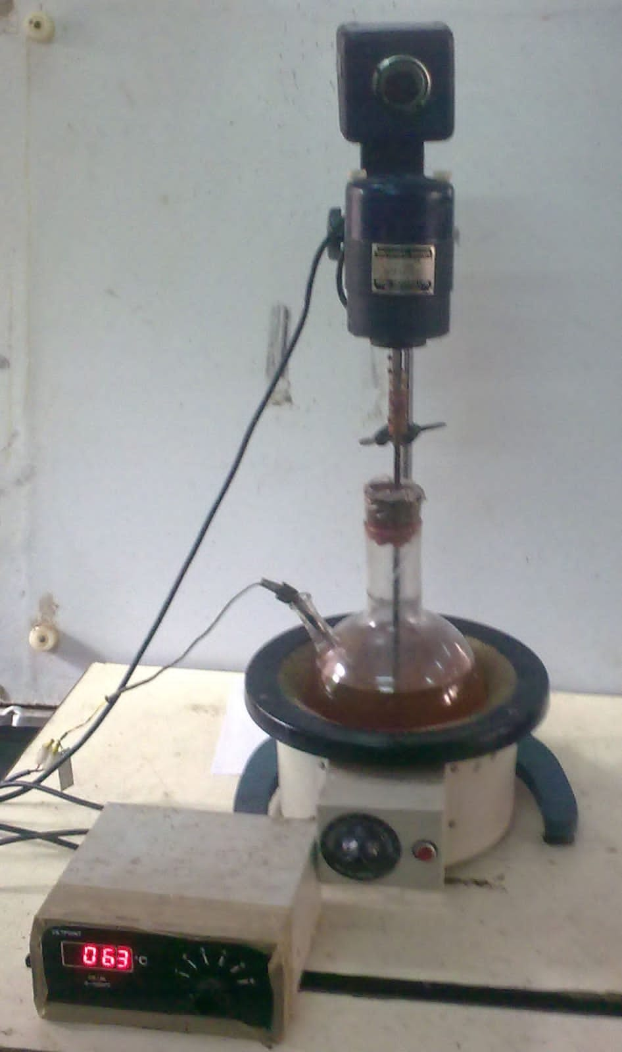

**Fig 5.1 Stirrer**

Transesterification which is chemical reaction takes places resulting in naseberry seed methyl ester (TSME). This resultant product is composed of biodiesel and glycerol. The biodiesel is separated from glycerol using a distillation unit. This takes about one day to settle. The glycerol is settled at the bottom and this is separated from biodiesel. Pure biodiesel is collected.

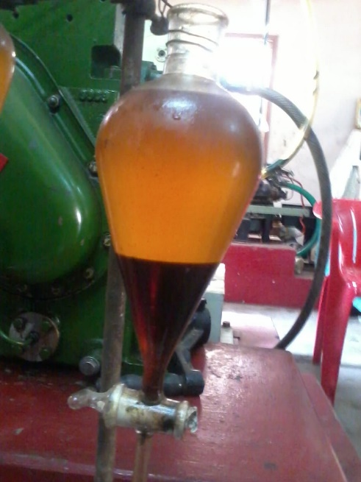

**Fig 5.2 Separation funnel for Naseberry Biodiesel and glycerol**

**5.3 CHARACTERISTIC ANALYSIS TEST OF PURE BIODIESEL**

Before taking performance blend test, preliminary characteristic analysis of pure diesel is conducted. Characteristics such as kinematic viscosity, flash point, fire point, gross calorific value, density etc.

**Table 5.1: Properties of biodiesel and diesel**

|  |  |  |  |
| --- | --- | --- | --- |
| **S. No** | **Characteristics** | **NASEBERRY**  **B100** | **DIESEL** |
| 1 | Kinematic viscosity @40°C in CST | 3.68 | 3.05 |
| 2 | Flash point °C | 86 | 56 |
| 3 | Fire point °C | 94 | 63 |
| 4 | Gross Calorific Value KJ/KG | 38,089.21 | 42,500 |
| 5 | Density in kg/m3 | 907 | 830 |

**5.4 WORK PROCESS DETAILS**

* Naseberry seed were purchased from Pallavan exports, Tiruvannamalai.
* Cold-press of seeds for naseberry oil was carried out in Sudarshan cold press oil mill, Chengalpet.
* Transesterification, Biodiesel characteristic test, Performance characteristic test and Emission test were done in Sri Venkateswara Engineering consultancy services, Kancheepuram.

**5.5 EXPERIMENTAL SETUP**

* The engine was coupled to an eddy current dynamometer for load measurement.
* The experiment was carried out in Kirloskar TV I Engine having power 5.20 kW. AVL smoke meter and AVL Di - gas analyser is connected with the engine suitably.
* Hydrocarbon, Carbon dioxide, Carbon monoxide, Oxygen and Oxides of nitrogen were measured by using AVL Di – gas analyser.
* The experiments were performed at load test; the engine was allowed to run with diesel at variable loads of No load, 25%, 50%, 75% and 100% at rated speed of 1500 rpm with full load of 5.2 kW.
* At each load readings corresponding to performance and emission characteristics are recorded. The results of these experiments are analysed and discussed in the forthcoming chapters.

After completing the experiment with Diesel, the experiment was conducted with B20, B40,B40+Al2O3 and B100 respectively.

**5.5.1 Engine Setup**

**Kirlosker TV 1**

**Table 5.2: Engine Specifications**

|  |  |
| --- | --- |
| Type | Water cooled, Four stroke |
| Number of cylinder | One |
| Bore | 87.5 mm |
| Stroke | 110 mm |
| Compression ratio | 17.5:1 |
| Maximum power | 5.2 kW |
| Speed | 1500 rpm |
| Dynamometer | Eddy current |
| Injection timing | 23° before TDC |
| Connecting Rod length | 234 mm |
| Swept volume | 661.45 cc |
| Orfice Diameter | 20 mm |
| Dyanometer arm length | 185 mm |

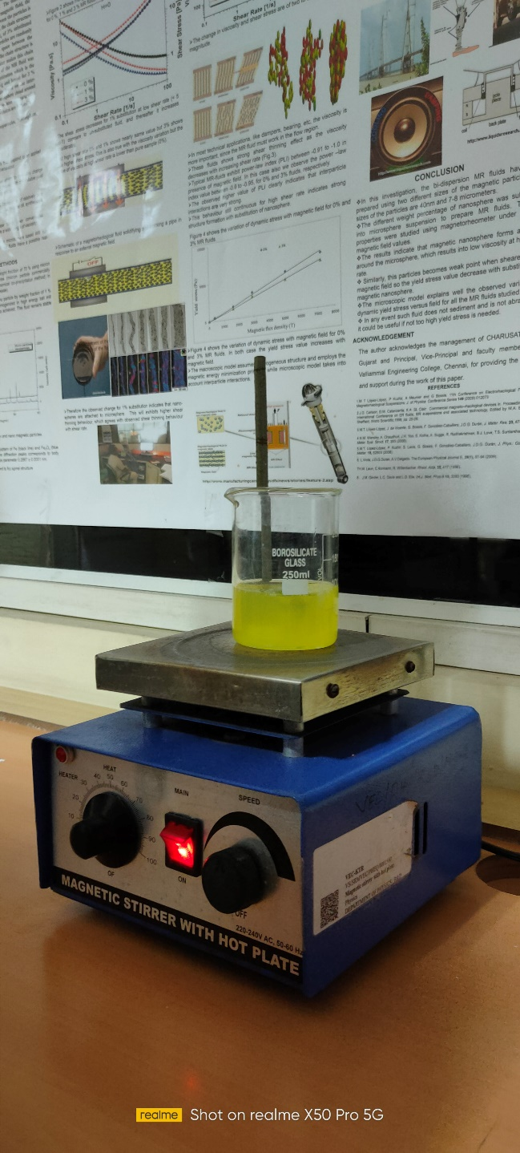

**Fig 5.3 Magnetic Stirrer**

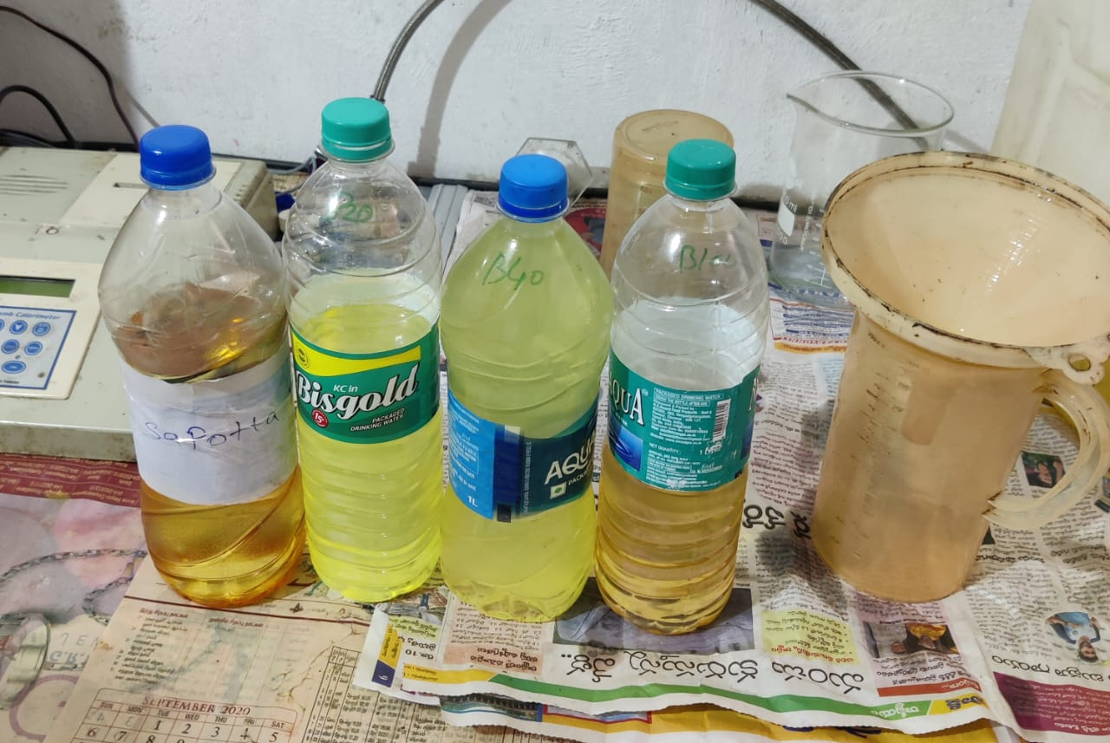

**Fig 5.4 Different blends of biodiesel and diesel**

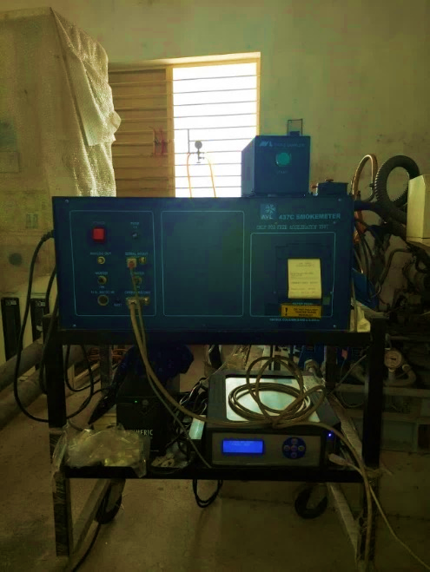**Fig 5.5 AVL smoke meter and AVL Di - gas analyser**

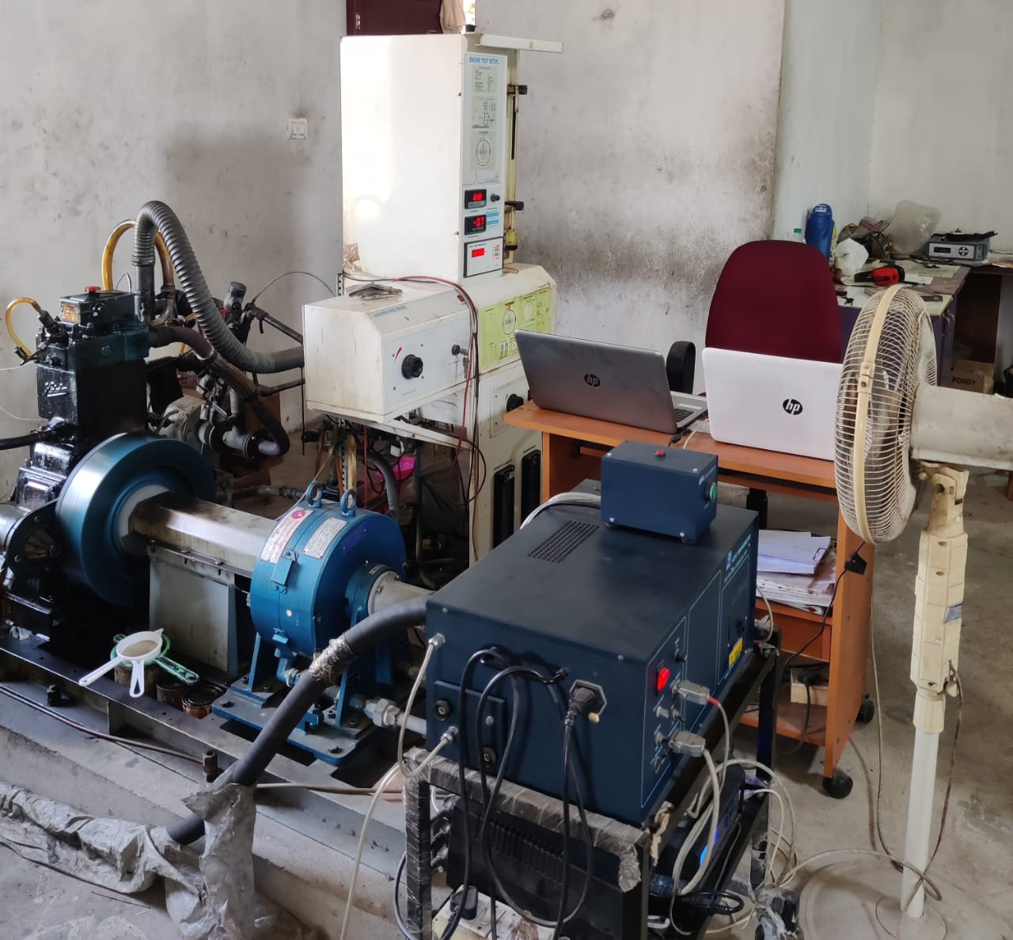

**Fig 5.6 Kirlosker TV 1 Engine setup**

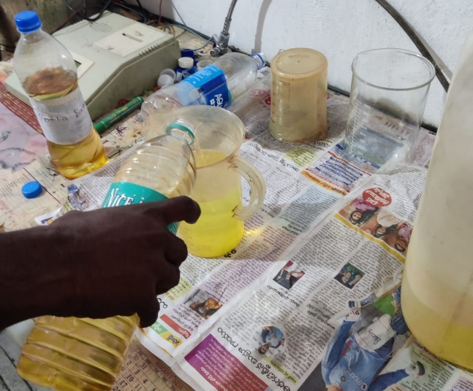 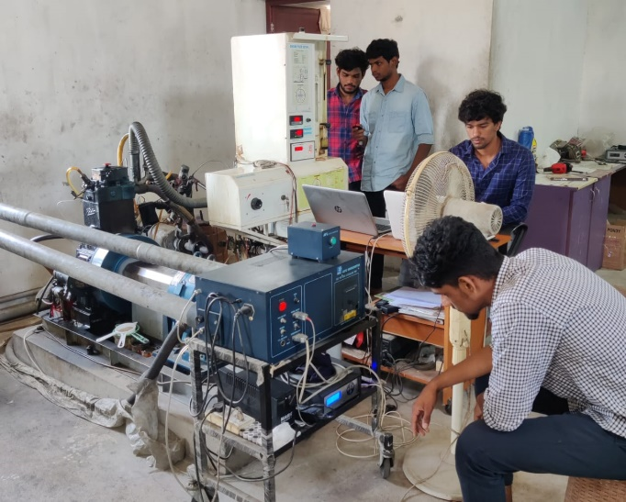

**Fig 5.7 Blending of biodiesel Fig 5.8 Performance characteristic test**

**5.6 OBSERVATION DATA**

**5.6.1 Performance Test**

**Table 5.3 Observation Data for B20**

|  |  |  |  |  |  |  |  |  |
| --- | --- | --- | --- | --- | --- | --- | --- | --- |
| Speed (rpm) | Load (kg) | Comp Ratio | T1 (̊ C) | T2 (̊ C) | T3 (̊ C) | T4 (̊ C) | T5(̊ C) | T6 (̊ C) |
| 1575 | 0.03 | 17.50 | 38.98 | 42.93 | 38.98 | 37.19 | 116.90 | 97.70 |
| 1524 | 4.50 | 17.50 | 39.00 | 47.86 | 39.00 | 38.71 | 177.75 | 139.50 |
| 1489 | 9.00 | 17.50 | 39.04 | 52.58 | 39.04 | 40.57 | 236.00 | 183.43 |
| 1480 | 13.51 | 17.50 | 39.15 | 57.59 | 39.14 | 42.67 | 299.82 | 230.38 |
| 1452 | 18.02 | 17.50 | 39.24 | 62.29 | 39.24 | 45.28 | 384.50 | 289.37 |

**Table 5.4 Observation Data for B40**

|  |  |  |  |  |  |  |  |  |
| --- | --- | --- | --- | --- | --- | --- | --- | --- |
| Speed (rpm) | Load (kg) | Comp Ratio | T1 (̊ C) | T2 (̊ C) | T3 (̊ C) | T4 (̊ C) | T5 (̊ C) | T6 (̊ C) |
| 1592 | 0.03 | 17.50 | 37.83 | 43.61 | 37.83 | 36.55 | 110.91 | 92.95 |
| 1511 | 4.50 | 17.50 | 37.86 | 47.21 | 37.86 | 37.81 | 176.59 | 137.92 |
| 1482 | 9.01 | 17.50 | 37.93 | 51.08 | 37.93 | 39.61 | 234.80 | 181.71 |
| 1484 | 13.50 | 17.50 | 37.99 | 55.83 | 37.99 | 41.96 | 299.55 | 229.50 |
| 1453 | 18.02 | 17.50 | 38.11 | 59.81 | 38.12 | 44.60 | 373.70 | 281.78 |

**Table 5.4.1 Observation Data for B40+AL2O3**

|  |  |  |  |  |  |  |  |  |
| --- | --- | --- | --- | --- | --- | --- | --- | --- |
| Speed (rpm) | Load (kg) | Comp Ratio | T1 (̊ C) | T2 (̊ C) | T3 (̊ C) | T4 (̊ C) | T5 (̊ C) | T6 (̊ C) |
| 1562 | 0.01 | 17.50 | 38.41 | 42.73 | 38.43 | 36.98 | 114.64 | 96.09 |
| 1521 | 4.50 | 17.50 | 38.43 | 47.67 | 38.44 | 38.72 | 180.68 | 141.63 |
| 1489 | 9.10 | 17.50 | 38.52 | 51.67 | 38.52 | 41.02 | 236.41 | 184.11 |
| 1476 | 13.50 | 17.50 | 38.58 | 55.58 | 38.59 | 43.11 | 295.84 | 227.52 |
| 1459 | 18.02 | 17.50 | 38.65 | 60.52 | 38.65 | 46.38 | 380.40 | 287.01 |

**Table 5.5 Observation Data for B100**

|  |  |  |  |  |  |  |  |  |
| --- | --- | --- | --- | --- | --- | --- | --- | --- |
| Speed (rpm) | Load (kg) | Comp Ratio | T1 (̊ C) | T2 (̊ C) | T3 (̊ C) | T4 (̊ C) | T5 (̊ C) | T6 (̊ C) |
| 1547 | 0.02 | 17.50 | 37.25 | 44.20 | 37.25 | 35.99 | 106.69 | 89.61 |
| 1506 | 4.50 | 17.50 | 37.30 | 46.61 | 37.29 | 37.04 | 173.47 | 135.27 |
| 1492 | 9.06 | 17.50 | 37.35 | 50.02 | 37.36 | 38.99 | 232.37 | 180.14 |
| 1464 | 13.50 | 17.50 | 37.43 | 53.08 | 37.44 | 40.88 | 293.35 | 225.68 |
| 1453 | 18.02 | 17.50 | 37.53 | 57.77 | 37.53 | 43.37 | 374.48 | 282.58 |

**Table 5.6 Observation Data for Diesel**

|  |  |  |  |  |  |  |  |  |
| --- | --- | --- | --- | --- | --- | --- | --- | --- |
| Speed (rpm) | Load (kg) | Comp Ratio | T1  (̊ C) | T2  (̊ C) | T3  (̊ C) | T4  (̊ C) | T5  (̊ C) | T6  (̊ C) |
| 1580 | 0.06 | 17.50 | 43.89 | 49.33 | 43.89 | 42.47 | 115.16 | 97.44 |
| 1538 | 4.50 | 17.50 | 43.98 | 52.31 | 43.99 | 43.27 | 183.33 | 145.32 |
| 1501 | 9.02 | 17.50 | 44.04 | 55.76 | 44.05 | 45.05 | 242.80 | 189.06 |
| 1474 | 13.50 | 17.50 | 44.13 | 59.34 | 44.13 | 47.38 | 307.69 | 238.09 |
| 1450 | 18.06 | 17.50 | 44.19 | 64.80 | 44.19 | 51.25 | 406.52 | 307.88 |

T1 = Engine cooling water inlet (̊ C)

T2 = Engine cooling water outlet (̊ C)

T3 = Calorimeter water inlet (̊ C)

T4= Calorimeter water outlet (̊ C)

T5 = Calorimeter exhaust gas in (̊ C)

T6 = Calorimeter exhaust gas out (̊ C)

**5.6.2 Emission Test**

|  |  |  |  |  |  |  |
| --- | --- | --- | --- | --- | --- | --- |
| **Load** | **CO** | **HC** | **CO2** | **O2** | **NOX** | **Opacity** |
| % | % | PPM | % | % | PPM | % |
| 00 | 0.062 | 77 | 1.33 | 19.11 | 121 | 7.2 |
| 25 | 0.055 | 73 | 2.84 | 16.78 | 507 | 14.7 |
| 50 | 0.049 | 76 | 4.35 | 14.66 | 970 | 36.2 |
| 75 | 0.052 | 84 | 6.11 | 12.19 | 1480 | 48.3 |
| 100 | 0.072 | 94 | 8.32 | 9.21 | 1892 | 66.2 |

**Table 5.7 Emission Observation Data for B20**

**Table 5.8 Emission Observation Data for B40**

|  |  |  |  |  |  |  |
| --- | --- | --- | --- | --- | --- | --- |
| **Load** | **CO** | **HC** | **CO2** | **O2** | **NOX** | **Opacity** |
| % | % | PPM | % | % | PPM | % |
| 00 | 0.101 | 78 | 1.49 | 18.95 | 107 | 16.3 |
| 25 | 0.062 | 72 | 3.11 | 16.51 | 501 | 28.9 |
| 50 | 0.068 | 85 | 4.74 | 14.3 | 1020 | 45.8 |
| 75 | 0.071 | 91 | 6.5 | 11.96 | 1527 | 56.8 |
| 100 | 0.077 | 106 | 8.5 | 9.2 | 1935 | 70.6 |

**Table 5.8.1 Emission Observation Data for B40+AL2O3**

|  |  |  |  |  |  |  |
| --- | --- | --- | --- | --- | --- | --- |
| **Load** | **CO** | **HC** | **CO2** | **O2** | **NOX** | **Opacity** |
| % | % | PPM | % | % | PPM | % |
| 00 | 0.074 | 78 | 1.4 | 19.03 | 114 | 10.9 |
| 25 | 0.055 | 73 | 3.05 | 16.58 | 515 | 19.6 |
| 50 | 0.045 | 77 | 4.39 | 14.66 | 1055 | 41.2 |
| 75 | 0.042 | 81 | 6.15 | 12.33 | 1560 | 50.6 |
| 100 | 0.074 | 97 | 8.42 | 9.17 | 1957 | 67.6 |

**Table 5.9 Emission Observation Data for B100**

|  |  |  |  |  |  |  |
| --- | --- | --- | --- | --- | --- | --- |
| **Load** | **CO** | **HC** | **CO2** | **O2** | **NOX** | **Opacity** |
| % | % | PPM | % | % | PPM | % |
| 00 | 0.126 | 94 | 1.53 | 18.84 | 90 | 28.2 |
| 25 | 0.089 | 84 | 3.46 | 16.3 | 551 | 45.3 |
| 50 | 0.069 | 87 | 5.27 | 13.83 | 1186 | 58.6 |
| 75 | 0.068 | 92 | 7.09 | 11.37 | 1685 | 74.7 |
| 100 | 0.133 | 106 | 9.34 | 8.53 | 1931 | 86.3 |

**Table 5.10 Emission Observation Data for Diesel**

|  |  |  |  |  |  |  |
| --- | --- | --- | --- | --- | --- | --- |
| **Load** | **CO** | **HC** | **CO2** | **O2** | **NOX** | **Opacity** |
| % | % | PPM | % | % | PPM | % |
| 00 | 0.036 | 5 | 1.7 | 18.22 | 171 | 1.6 |
| 25 | 0.026 | 9 | 3.84 | 15.01 | 660 | 8.4 |
| 50 | 0.027 | 16 | 5.75 | 12.24 | 1173 | 16.5 |
| 75 | 0.034 | 26 | 7.67 | 9.4 | 1544 | 36.8 |
| 100 | 0.312 | 49 | 10.2 | 5.42 | 1694 | 64.6 |

**5.5 CALCULATION**

* Total Fuel Consumption [T.F.C],

= q/t density

kg/S (or)

=1.704 Kg/hr

* Brake Power [BP], kW

Where,

BP = Brake power in kilowatts

W = Calculated load in Newton.

= 5.2 kW

=176.58 N.

* Indicated Power (I.P)

* Brake thermal Efficiency, %

= 0.25 (or) 25%

* Indicated thermal efficiency

=

= 0.25 (or) 25%

Chapter 6

**RESULTS AND CONCLUSION**

**6.1 Performance result data**

**Table 6.1 Result Data for B20**

|  |  |  |  |  |  |  |  |  |
| --- | --- | --- | --- | --- | --- | --- | --- | --- |
| Torque (Nm) | BP (kW) | FP (kW) | IP (kW) | BMEP (bar) | IMEP (bar) | BTHE (%) | ITHE (%) | Mech Eff. (%) |
| 0.06 | 0.01 | 2.36 | 2.37 | 0.01 | 2.73 | 0.23 | 57.28 | 0.40 |
| 8.17 | 1.30 | 2.84 | 4.14 | 1.55 | 4.93 | 18.40 | 58.48 | 31.47 |
| 16.34 | 2.55 | 2.71 | 5.26 | 3.10 | 6.40 | 26.95 | 55.61 | 48.47 |
| 24.51 | 3.80 | 2.72 | 6.52 | 4.66 | 7.99 | 30.63 | 52.57 | 58.26 |
| 32.71 | 4.97 | 2.63 | 7.61 | 6.21 | 9.51 | 32.38 | 49.54 | 65.37 |

**Table 6.2 Result Data for B40**

|  |  |  |  |  |  |  |  |  |
| --- | --- | --- | --- | --- | --- | --- | --- | --- |
| Torque (Nm) | BP (kW) | FP (kW) | IP (kW) | BMEP (bar) | IMEP (bar) | BTHE (%) | ITHE (%) | Mech Eff. (%) |
| 0.06 | 0.01 | 2.50 | 2.51 | 0.01 | 2.86 | 0.24 | 60.72 | 0.40 |
| 8.17 | 1.29 | 2.86 | 4.15 | 1.55 | 4.99 | 16.85 | 54.13 | 31.13 |
| 16.35 | 2.54 | 2.93 | 5.46 | 3.11 | 6.69 | 23.89 | 51.44 | 46.44 |
| 24.51 | 3.81 | 2.72 | 6.53 | 4.66 | 7.98 | 28.06 | 48.09 | 58.34 |
| 32.71 | 4.98 | 2.63 | 7.61 | 6.21 | 9.50 | 30.12 | 46.03 | 65.43 |

**Table 6.2.1 Result Data for B40+AL2O3**

|  |  |  |  |  |  |  |  |  |
| --- | --- | --- | --- | --- | --- | --- | --- | --- |
| Torque (Nm) | BP (kW) | FP (kW) | IP (kW) | BMEP (bar) | IMEP (bar) | BTHE (%) | ITHE (%) | Mech Eff. (%) |
| 0.02 | 0.00 | 2.29 | 2.29 | 0.00 | 2.66 | 0.09 | 55.43 | 0.16 |
| 8.17 | 1.30 | 2.92 | 4.22 | 1.55 | 5.03 | 18.38 | 59.54 | 30.86 |
| 16.51 | 2.57 | 2.83 | 5.40 | 3.14 | 6.58 | 25.65 | 53.83 | 47.66 |
| 24.50 | 3.79 | 2.78 | 6.57 | 4.66 | 8.07 | 29.17 | 50.59 | 57.67 |
| 32.71 | 5.00 | 2.70 | 7.70 | 6.21 | 9.57 | 31.36 | 48.31 | 64.92 |

**Table 6.3 Result Data for B100**

|  |  |  |  |  |  |  |  |  |
| --- | --- | --- | --- | --- | --- | --- | --- | --- |
| Torque (Nm) | BP (kW) | FP (kW) | IP (kW) | BMEP (bar) | IMEP (bar) | BTHE (%) | ITHE (%) | Mech Eff. (%) |
| 0.04 | 0.01 | 2.42 | 2.43 | 0.01 | 2.85 | 0.14 | 52.76 | 0.27 |
| 8.18 | 1.29 | 3.07 | 4.35 | 1.55 | 5.25 | 16.00 | 54.02 | 29.61 |
| 16.44 | 2.57 | 2.95 | 5.52 | 3.12 | 6.71 | 23.48 | 50.46 | 46.52 |
| 24.50 | 3.76 | 2.87 | 6.63 | 4.66 | 8.22 | 27.19 | 47.97 | 56.67 |
| 32.71 | 4.98 | 2.63 | 7.61 | 6.21 | 9.50 | 29.80 | 45.58 | 65.39 |

**Table 6.4 Result Data for Diesel**

|  |  |  |  |  |  |  |  |  |
| --- | --- | --- | --- | --- | --- | --- | --- | --- |
| Torque (Nm) | BP (kW) | FP (kW) | IP (kW) | BMEP (bar) | IMEP (bar) | BTHE (%) | ITHE (%) | Mech Eff. (%) |
| 0.10 | 0.02 | 2.14 | 2.15 | 0.02 | 2.47 | 0.41 | 52.31 | 0.78 |
| 8.17 | 1.32 | 2.66 | 3.98 | 1.55 | 4.69 | 18.65 | 56.42 | 33.06 |
| 16.37 | 2.57 | 2.66 | 5.23 | 3.11 | 6.32 | 27.36 | 55.63 | 49.18 |
| 24.51 | 3.78 | 2.45 | 6.24 | 4.66 | 7.68 | 32.17 | 53.05 | 60.65 |
| 32.78 | 4.98 | 2.46 | 7.44 | 6.23 | 9.31 | 33.86 | 50.63 | 66.89 |

**6.2 Performance Graphs**

**Fig 6.1 Graphical Representation of Specific fuel consumption**

**Fig 6.2 Graphical Representation of Brake thermal efficiency**

**Fig 6.3 Graphical Representation of Mechanical efficiency**

**6.3 Performance Characteristics**

The variation of specific fuel consumptions (SFC) of different blended fuels and those of pure biodiesel and diesel are presented in figure 6.1. The blends follows a similar trend to that of diesel. The SFC of biodiesel blend B40+Al2O3 is higher compared to diesel. It observed that the blend of 20% of naseberry seed biodiesel and 80% of diesel has similar specific fuel consumption to that of pure diesel.

The figure 6.2 indicates the variation of brake thermal efficiency of the engine with load for different naseberry seed biodiesel blends and diesel. The brake thermal efficiencies of the pure naseberry seed biodiesel fuel, diesel and the blends increase and the maximum brake thermal efficiencies for different cases are obtained at maximum load.

Figure 6.3 shows mechanical efficiency of blends, pure biodiesel and pure diesel. It is observed that B20 has 1.61 % more mechanical efficiency compared to pure diesel.

**6.4 Emission Graphs**

**Fig 6.4: Graphical Representation of Carbon monoxide level**

**Fig 6.5: Graphical Representation of Hydrocarbon level**

**Fig 6.6: Graphical Representation of Nitrogen Oxides level**

**Fig 6.7: Graphical Representation of Opacity level**

**6.5 Emission Characteristics**

The engine emission test gives a direct measure of the environmental impact of a fuel used in an internal combustion engine. Figure 6.4 shows the amount of CO emissions at different loads for different blended fuels as well as pure biodiesel and pure diesel. The CO emission is found to increase with load. The CO emission of B100 is comparatively less compared to pure diesel. The figure 6.4 shows nitrogen oxides of different blends of biodiesel and diesel. The NOx emission for B20 naseberry seed biodiesel is 1892 ppm at maximum load and that of pure diesel is 1950 ppm. The nitrogen oxides of B20 is less compared to diesel. We can see that from figure 6.6, the opacity of B20 is less compared to other blends. The biodiesel blend has high viscosity, larger fuel droplet sizes and decrease in fuel air mixing rate. These are the factors involved to increase the opacity of biodiesel blends. The various emission test shows that B20 has better emission characteristics compared to other blends.

**6.6 Conclusion**

Involvement of mechanical energy into the automotive sector has led to much higher output.  Replacing animate power has caused remarkable improvement in terms of time consumption and cost.  Diesel engine plays a pivotal role in this improvement program. Many heavy vehicles operations are performed with the help of diesel engine.   But on the account of India’s heavy dependency on fossil fuel, it’s need of the hour to find a suitable alternative.  Now, biodiesel appears to be promising choice as alternative to diesel as it can be prepared from various feed stocks which can easily be available throughout the country.  It is also proved that emission characteristics of a biodiesel driven engine is far better than that of the diesel engine with very little compromise in the brake specific fuel consumption, engine torque and power

* B20 has less emission of nitrogen oxides compared to that of diesel.
* It is observed thar carbon monoxide, hydrocarbon and nitrogen oxide emission of B100 is less comparatively however it shows higher smoke opacity. The specific fuel consumption of B100 is also significantly higher.
* When we compared B40 with nano additives Al2O3 and B40 without nano additive the B40+Al2O3 gives us a lower Specific Fuel Consumption, reduced smoke with less hazardous emissions than B40 blend. There is also quite a significant increase in the Brake Thermal Efficiency with better combustion.
* Of all the blends, B20 shows better mechanical efficiency and follows a similar trend of diesel for specific fuel consumption.

Hence use of biodiesel has to become an integral part of the mechanical assistance system in the heavy vehicle of this country for its sustainable development.  It will also reduce the dependency on foreign currencies by means of meeting its fuel demands on its own to some extent in near future.  Finally, government has to develop favourable environment through policy reforming to promote the use of biodiesel in the heavy vehicle sector.

**References**

1. Srinivasarao, Arudra & Kumar, Arudra. (2015). Naseberry seed processing and by-products. Agricultural Engineering International : The CIGR e-journal. 17. 200-204.
2. Ferreira, Weder N. Et al. THERMODYNAMIC PROPERTIES OF NASEBERRY SEEDS (Naseberryus indica L.). Engenharia Agrícola [online]. 2020, v. 40, pp. 740-746. Epub 23 Nov 2020. ISSN 1809-4430.
3. Mingxin Guo, Weiping Song, Jeremy Buhain, Bioenergy and biofuels: History, status, and perspective, Renewable and Sustainable Energy Reviews, Volume 42, 2015, Pages 712-725, ISSN 1364-0321.
4. Shweta J. Malode, K. Keerthi Prabhu, Ronald J. Mascarenhas, Nagaraj P. Shetti, Tejraj M. Aminabhavi, Recent advances and viability in biofuel production, Energy Conversion and Management: X, Volume 10, 2021, 100070, ISSN 2590-1745.
5. Rajalingam. A. & S P. Jani, A Senthil Kumar, M Adam Khan, M.A.. (2016). Production methods of biodiesel. 8. 170-173.
6. Montcho Papin S., Konfo T. R. Christian, Agbangnan D. C. Pascal, Sidouhounde Assou and Sohounhloue C. K.Dominique Comparative Study of Transesterification Processes for Biodiesel Production Elixir Appl. Chem. 120 (2018) 51235-5124.
7. Theodoros Grigoratos, Georgios Fontaras, Barouch Giechaskiel, Nikiforos Zacharof, Real world emissions performance of heavy-duty Euro VI diesel vehicles,Atmospheric Environment,Volume 201,2019,Pages 348-359,ISSN 1352-2310.
8. Chris Ruehl , Chandan Misra , Seungju Yoon , Jeremy Smith , Mark Burnitzki , Shaohua Hu , John Collins , Yi Tan , Tao Huai & Jorn Herner (2021): Evaluation of Heavy-Duty Vehicle Emission Controls with a Decade of California Real-World Observations, Journal of the Air & Waste Management Association.
9. Tumba Kaniki, Durrett Timothy P., Niju Subramaniapillai, Ojumu Tunde Victor, Tango Martin Safari, Betiku Eriola Editorial: Plant Seed Oils and Their Potential for Biofuel Production JOURNAL=Frontiers in Energy Research, VOLUME=9, 2021, ISSN=2296-598X.
10. Konstantin Pikula , Alexander Zakharenko , Antonios Stratidakis , Mayya Razgonova, Alexander Nosyrev , Yaroslav Mezhuev , Aristidis Tsatsakis & Kirill Golokhvast (2020) The advances and limitations in biodiesel production: feedstocks, oil extraction methods.
11. Ganesan A., Nawkarkar P., Kumar S., (2020). Technological advancement in biofuel from genetic engineered algae and future prospectives. Frontiers Journal of Renewable Energy, 1(1), 1-43.
12. Roberts, L.G. (2014). *Encyclopedia of Toxicology, Biofuels., 469–475.*Doi:10.1016/b978-0-12-386454-3.01054-x.
13. W. L. Ahlgren, "The Dual-Fuel Strategy: An Energy Transition Plan," in Proceedings of the IEEE, vol. 100, no. 11, pp. 3001-3052, Nov. 2012, doi: 10.1109/JPROC.2012.2192469.
14. J. Van Gerpen, B. Shanks, and R. Pruszko Iowa State University D. Clements Renewable Products Development Laboratory G. Knothe USDA/NCAUR (2004) Biodiesel Production Technology: National Renewable Energy Laboratory, Colorado, NREL/SR-510-36244.
15. S. Kent Hoekman, Amber Broch, Curtis Robbins, Eric Ceniceros, Mani Natarajan, Review of biodiesel composition, properties, and specifications, Renewable and Sustainable Energy Reviews, Volume 16, Issue 1, 2012, Pages 143-169, ISSN 1364-0321.
16. Corseuil, H.X., Monier, A.L., Gomes, A.P.N., Chiaranda, H.S., do Rosario, M., Alvarez, P.J.J., 2011. Biodegradation of soybean and castor oil biodiesel: implications on the natural attenuation of monoaromatic hydrocarbons in groundwater. Ground Water Monit.Remed., 1–8.
17. S K Dash and P Lingfa 2018 ‘An overview of biodiesel production and its utilization in diesel engines’ IOP Conf. Ser.: Mater. Sci. Eng. 377 012006.
18. Aktawan, Agus & Zahrul, M. (2019). Small-scale production of biodiesel through transesterification process of waste or used cooking oil. IOP Conference Series: Earth and Environmental Science. 245. 012047. 10.1088/1755-1315/245/1/012047.
19. Khan, Abdul Majeed, Manzoor, Sana, Kalam, Shazia, Wali, Shoukat, Safi, Abdul Hadi, Hussain, Muhammad Shoukat, Yasmeen, Kousar, Shah, Syed Wali, & Ahmed, Muhammad Naeem (Dec 2019). Solar irradiated and metallurgical waste catalyzed conversion of waste cooking oil to biodiesel. Materials Research Express (Online), 6(12), 18.
20. Agustian, Egi & Praptijanto, Achmad & Darwin, Sebayang & Anika Zafiah M., Rus & Hasan, Sulaiman. (2016). Biodiesel production from waste cooking oil by using ultrasonic tubular reactor. International Journal of Innovation in Mechanical Engineering and Advanced Materials. 2. 31. 10.22441/ijimeam.2016.1.006.
21. Nigam, P.S. and Singh, A. (2011), Production of liquid biofuels from renewable resources, Progress in Energy and Combustion Science, 37(1): 52–68.
22. Reddy ANR, A. A. Saleh, Md. Saiful Islam, S. Hamdan, and Md. Abdul Maleque “Biodiesel Production from Crude Jatropha Oil using a Highly Active Heterogeneous Nanocatalyst by Optimizing Transesterification Reaction Parameters” Energy & Fuels **2016** 30 (1), 334-343.
23. M.S. Habib, M. Tayyab, S. Zahoor, B. Sarkar ‘Management of animal fat-based biodiesel supply chain under the paradigm of sustainability’ : Energy Convers Manage, 225 (2020), Article 113345.
24. D.J. Garcia, F. You ‘Addressing global environmental impacts including land use change in life cycle optimization: studies on biofuels :J Cleaner Prod, 182 (2018), pp. 313-330.